moKee Landing Page copy

1) Top bday banner
1 - 2 sentences max - introducing bday + CTA to scroll down to see all the offers

It’s our birthday - we want to celebrate with you!
Scroll down to see our offers

2) Offers summary

Please create a clear header - that those are all offers for moKee bday that the offers CAN be combined
What we have for bday:

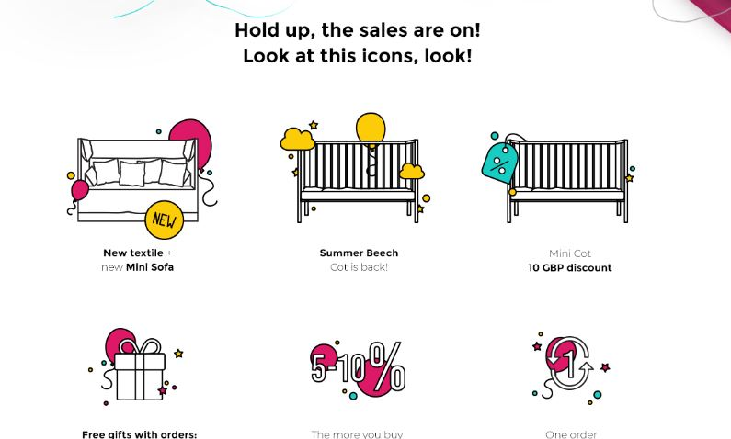

Here’s your goody bag-
All offers can be combined!

- Stylish new products
We have a brand new cover for the Mini-Cot, converting it to a sofa, and a brand new textile range!

- Our bestseller is back
You LOVED the Summer Beech Cot, so it’s back for a limited time only!

- More to buy? More to save!
Get up to 10% off bulk orders and bundles

- Competition - Be in it to win it!
One order this month will be entirely refunded

- Free gift with every purchase!
A set of beautiful candles (+ vitamins too if you spend over £50!)

3) "the more you buy the more you save" section - pls review the copy we have now plus add he free gifts (candles and VITL samples)
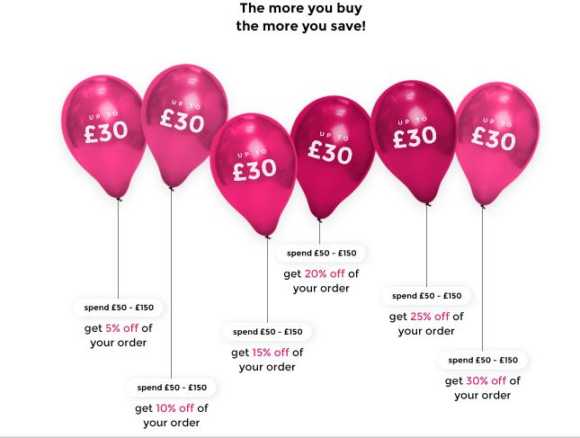
More to buy? More to save!
(copy underneath balloons is fine)

Our present to you
You’ll also receive a set of our gorgeous ‘cloud candles’, ideal for any celebration!
If your order value is over £50, you’ll also get some VITL Pregnancy Vitamins, perfect for your growing bump.

4) section for new products - a slider -> Sofa / Textile / Summer Beech Cot / Candles
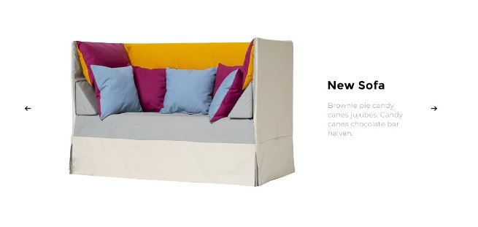
pls follow the design
Sofa

Mokee Mini-Cot to Sofa
You can now transform your Mini-Cot into a comfortable and practical sofa for your little ones! Suitable for 3-8years old. Shop Now

Textile
Geometric Dream
Our new triangle patterned print comes in blush pink or navy blue. The super-soft fabric is available in bedding, jersey sets, sleepy bags, blankets and more. Shop Now

Summer Beech Cot
Summer Beech Cot
For a limited time only, we’re bringing back our stunning handcrafted summer beech cot. Bring some sunshine into your nursery! Shop Now

Candles
Wishing Cloud Candles
Attach your dreams and wishes to a cloud, and let them float away. These cute cloud candles are perfect for any birthday cake. Free with every purchase! Shop Now

5) Cot discount - pls follow the design
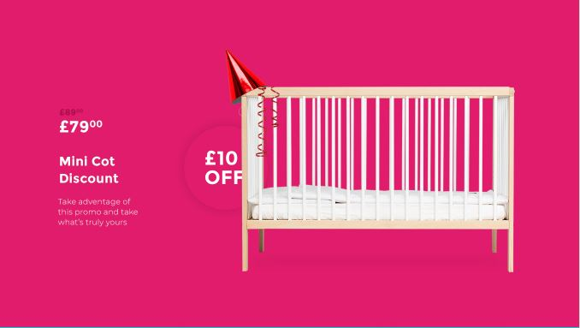
Save on our best-selling Mini-Cot
We love the product as much as you, so here’s £10 off

6) Refund section - please follow the design (the idea is after purchase people will be able to register their purchase in the competion app and one order will be chosen to be refunded - no maximum or minimum price

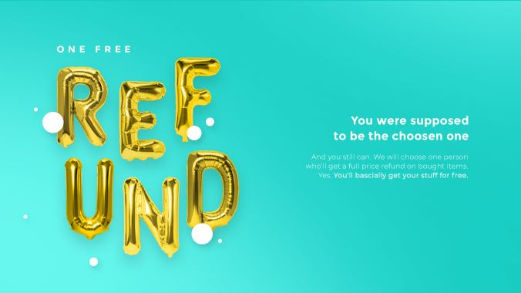

Be in for a chance to win

Anyone who orders from moKee this month will be automatically entered in a competition for a chance to win the full value of their order back.
One lucky customer will get their items for free - no minimum or maximum spend required!

CTA 1: Shop now to enter
CTA 2: Recently ordered? You can still enter!

6) Bundles section - pls review the copy
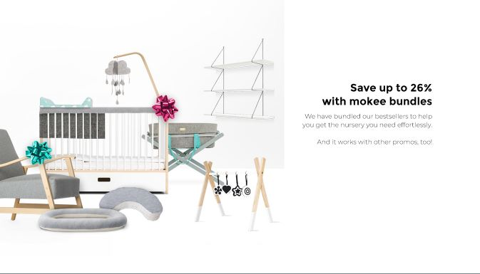
Buying in bulk? Save up to 26%
Our moKee bestseller bundles allow you to save even more, allowing you to get your entire nursery. All of our other offers are also included!

