A Cashless Society: The Introduction of the Cashless ATM at Events
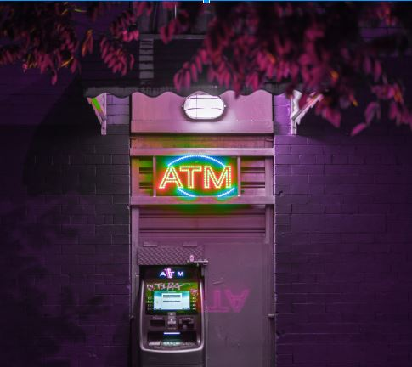

When was the last time you got cash out of an ATM?

If you can’t quite remember, you’re not alone. The ‘cashless’ society is already making its mark in society, as recent evidence uncovers. Colliers International Research has found that ATM withdrawals have been steadily on the decline for nearly a decade, falling by 28 per cent in both the number of ATM withdrawals and total amount withdrawn, from January 2009 to July 2017.The introduction of Chip and Pin, Apple Pay, and many other virtual payments mean that consumers are much less likely to carry cash around with them. If you’re organising an event, this important change in the way we make transactions will have an effect on the entire industry in years to come, so it pays to be ahead of the game.

Currently, shopping centre landlords and tenants are now bracing themselves for the next phase - the exit of ATM’s from malls. Already, shopkeepers are no longer renewing their lease for the ATM’s they have in place, meaning that up and down the country, cash machines are slowly disappearing. This means alternative payment methods are being introduced by many retailers.

Starbucks are already accepting mobile payments, which is proving increasingly popular, especially when compared to consumers using Apple, Google, or Samsung Pay. Starbucks offer reward points for using their mobile payment system, and it has hugely increased customer loyalty. By going cashless, companies have access to a far greater range of transactional data. They can far better predict customers spending habits, and the ways they interact with their brand.

Customers don’t have to worry about hygiene either, or running out of money - a simple swipe or top up on their phone means that they can complete the transaction.

So should we make our events cashless?

Above all, a cashless society could make society more transparent. But how will this impact the event industry, where currently, cash is king?

It will make entry systems such as RFID ticketing more valuable and scalable.

Imagine not only encoding your customers ticket information in a wristband; but also allowing them to preload their spending money for a festival, allowing them to quickly purchase drinks and snacks. Not only will this help customers feel more safe at events, it could drastically improve the margins of festival owners, as customers no longer spend time in line waiting to draw cash out of an ATM.

Allowing mobile top-ups on an RFID wristband or even creating your own event-branded app will allow for purchases to be tracked and measured, thus improving your financial reporting.

For the first time, event organisers will be able to receive truly accurate data about all aspects of their event - how many purchases were made, which vendors were the most popular, how much was spent by each person, and much more.

For events such as festivals, the benefits could be wide-reaching. Having the ability to get live, real-time data on attendees means that their experience can be continually modified and improved. It also makes it safer for your staff and vendors - there’s no carrying large quantities of money around, and they can be sure their income is accurate.
At music events and expos, connectivity will still continue to be an issue for the foreseeable future, and to supply ATM machines with internet for all cards is simply not an option.

In the future, customers at events will visit a cashless ATM point, which instead of withdrawing physical cash, will dispense an RFID card or wristband which can be topped up as many times as they like and used at vendors onsite.
This new way of transacting is certainly quicker, too. Lines at events will be reduced with a faster payment system, and this can only have a beneficial effect on customer’s experience.

What’s more, it’s even possible to encode emergency information into the wristband - ideal for large-scale events such as festivals. Knowing a person is epileptic or has an allergy could be life saving information, as you can link all customer data to a cloud-based CMS.

Are there any downsides to not carrying cash?

Of course. There are, for example, things that could go wrong. Detonate Festival in the UK first introduced cashless payments in 2015, with the use of their RFID wristbands. There were, as to be expected, a few teething problems - customers made complaints on their Facebook page about the wristbands not working properly, or they weren’t sure how to get their money refunded if they didn’t spend it all.

Technical glitches can put your whole event in jeopardy when you’re cashless, but fortunately digital payments have moved forwards significantly since then.

Cost is another issue why many event organisers have steered away from digital payments thus far. It’s important to keep your event budget under control. Installing RFID throughout your event can be costly, not to mention require major infrastructure changes. However, cost-effective solutions are being released all the time, and they are so simple to integrate into your business that training your staff will be a breeze.

What about your vendors? At a large event like a festival, vendors may be so used to cash that it may unnerve them to hear they’ll be taking no physical cash. Breaking this barrier depends on your relationship with your vendors, and educating them on the benefits of a cashless event.

The future could be cashless

Is the future definitely cashless? The jury’s out. Sweden, a country that only does 2% of it’s transactions in cash, is reconsidering it’s decisions, as more companies gain monopoly and those that don’t adopt digital are being left behind. For the event industry though, it could be a beneficial decision.

Going cashless isn’t for all event managers. For small-scale events, cash will win out everytime. When your ticket sales go into the thousands however, a cashless ATM just may be the way forward to help you build a winning customer experience.

Ultimately, going digital with your payments allows you to make smarter, data-driven decisions, which can be invaluable as a festival manager.

Want to read more insider event-based content? Subscribe to the Audience Tools Blog or follow us on social.

