The Power of Silence

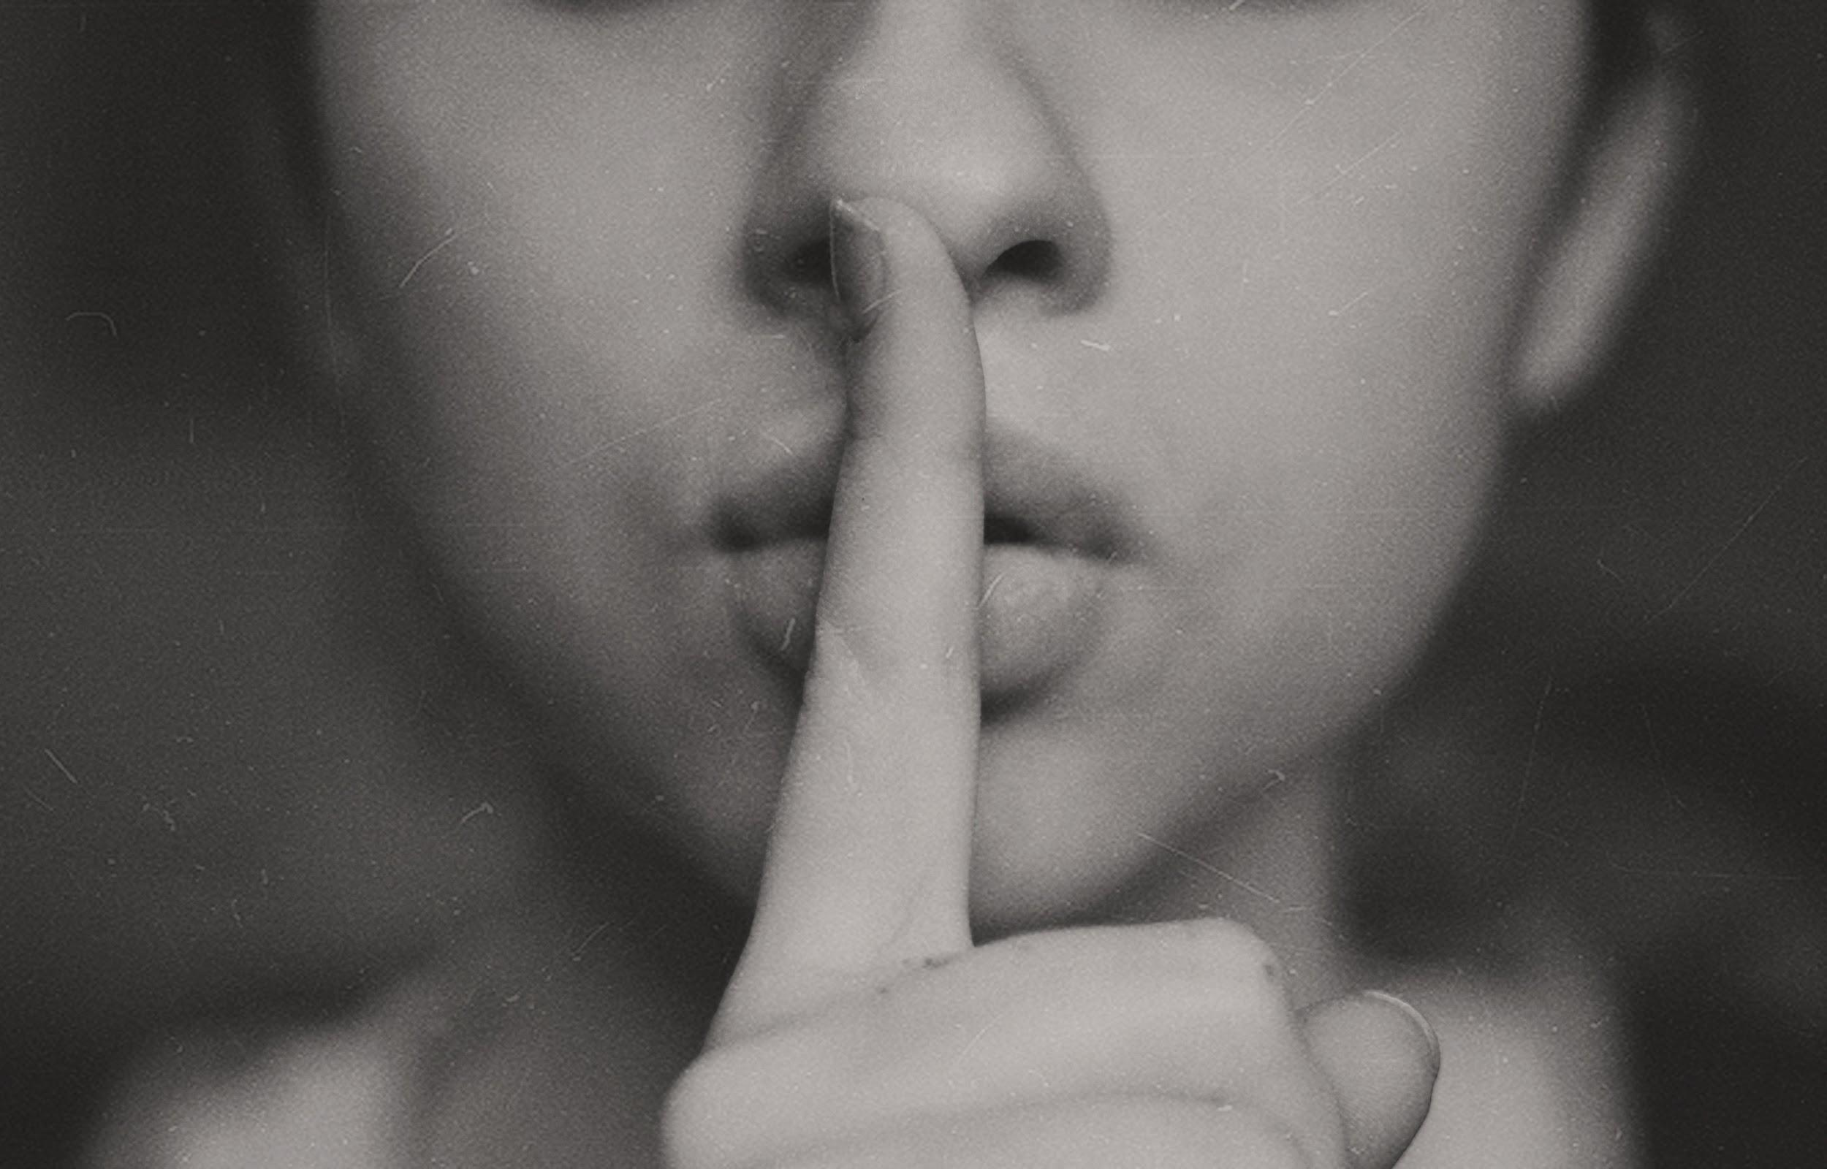

Silence. It’s one of the things many people crave in today’s hectic, fast-paced world, and it is now a luxury for many.

When was the last time you experienced true silence?

Pure, unbroken silence is not something that many can enjoy in today’s modern ways of living.

Perhaps you’re lucky enough to enjoy the peace and quiet of a rural dwelling, but if not, you’ll know that noise pollution really can be a real health risk.

Finding silence in a noisy world

In fact, elevated levels of noise have been linked to several deaths in London, as it directly correlated with inability to sleep, raised blood pressure, and higher stress levels.

A busy, bustling city may be exciting, but it can also strip us of the soft, nurturing effect that silence can give us.

Silence is powerful - and we often turn to it when in need of deep rest or inward attention.

Libraries have silent areas for thinking time. Spas have silence for relaxation, and we collectively hold a minute’s silence for reverence, and reflection.

The benefits of silence

Silence has been shown to have a dramatic effect on our mind, body, and overall wellbeing.

A 2006 study in Heart magazine revealed that silence can release tension in the brain and body in just two minutes.

Researchers have found that being daily exposed to two hours of silence would increase the regeneration of nerve cells in the hippocampus. The latter is responsible for learning, memory and emotions.

Ultimately, silence is one of the best cures for stress relief. We’re all keenly aware of the debilitating effects of stress, which can contribute to aging, including heart disease, metabolic syndrome, type 2 diabetes and certain types of disability, and even early death.

Silence can also help you get in touch with your emotions and inner self, too. Many people explore this on a 10 day silent meditation or solitary retreat.

Leonardo Da Vinci said “Nothing strengthens authority so much as silence”. But what did he mean?

Well, the beauty of silence is that it is filled with meaning, with possibility. You’ll know that from hearing a good public speaker that silence is used to create important pauses, and moments of self-reflection.

Silence allows us to go inward. With the absence of external noise, we are left with our own thoughts and feelings. It’s just you, and your thoughts.

This can be a positive experience or a negative experience, depending on how your mindset is. If you’re an introvert or a Highly Sensitive Person who needs to ‘recharge’ after the time spent with people, silence can be a soothing balm.

We experience silence most often when we’re alone.

Solitude and silence

Could solitude be the way to recharge ourselves with silence?

Nikola Tesla thought so:
“The mind is sharper and keener in seclusion and uninterrupted solitude. Originality thrives in seclusion; free of outside influences beating upon us to cripple the creative mind. Be alone—that is the secret of invention: be alone, that is when ideas are born.” ~ Nikola Tesla

Perhaps there is a connection to our unconscious minds when we are alone in silence, without anyone to speak to. A research paper in 2003 explored how solitude was associated with “freedom, creativity, intimacy, and spirituality.”

In today’s technologically driven-world, solitude can be the key to embracing new ideas. Perhaps switching off the laptop, leaving your phone at home and taking a walk in the park is the right thing to do to give our minds a well-earned rest.

All of our distractions are eliminated with silence; with no-one to talk to and nothing to do, our minds can roam free.

Should we then, actively take time out alone to experience silence?

Embracing silence

When faced with silence, you are completely in the present moment. By attuning your ears to the absence of noise, you are left with no sound to fill the air.

We can use silence to help us become more mindful. When it is silent, we notice things more. We might notice the crunch of our boots on the frost-covered leaves, or the sound of the birds singing, or even the way the wind rustles through the trees.

Silence allows us to gather our thoughts. It gives us a mental pause, allowing us to learn from past experiences, reflect on things we have done and maybe gain insights into problems that have been troubling us.

Silence is a powerful tool. It can calm us, refresh us, and inspire us - if we only perhaps learn to appreciate it.

